Funding Proposal to Caritas Committee, OESSH Netherland
Project title: Three different computer programs and new computers for Mother of Mercy Clinic in Zerqa
Project ID: M3367
Project Year: 2019
Applicant Name: CNEWA/Pontifical Mission
Postal and e-mail addresses: P.O. Box 6495, Amman 11118 – Jordan
pm.amman@pontificalmission.jo
Tel. 962 6 4649-240
Fax. 962 6 4649-282
Task and position: Ra’ed A. Bahou, Regional Director

Description:
Mother of Mercy clinic have three different computer programs: one in the registration unit, the second in the laboratory, and the third in the pharmacy.
The Sister in Charge had been invited to a meeting with the Health Department in Zarqa, Jordan, and they were required for additional information regarding the patients, including the previous data they provide every month. The additional information is:

How many Iraqi and Syrian refugee patients are visiting the clinic?
How many refugee children had vaccinations and what type of vaccine had been given?
How many patients come to the clinic from other countries Chechnya, Bangladesh, Burma, Egypt and others?
How many children come to the clinic from other countries, and who had vaccinations and what type of vaccine had been given?
How many children who should take the vaccine and left behind? The reason or another for not being vaccinated?
What is the majority of the patients and from which areas?
Other additional queries…?

To respond to these demands from the Department of Health in Zarqa, the clinic is in need to new integrated computer programs, through which they can provide all requirements to better serve the patients and the community as a whole. By providing all these data, the Department of Health will also reach its main goal of reducing infectious diseases, control and monitor the vaccinations’ campaigns appropriately, and reaching all mothers and children without discrimination for enhancing their health. The clinic should follow the instructions of the Health Department and start using the three programs in the first of January 2019.

Here under more details about the registration unit, laboratory and Pharmacy, which need new developed computer programs:
1- The clinic started the registration system in 2005, it is divided into three categories: general cases files (yellow color), child files / vaccines (blue), and pregnant women files (pink color).
** In the general case files containing the patient's initial information such as full name, date of birth, date of first visit, date of last visit and place of residence.
** In child files and vaccines, it contains information about the child, such as the full name of the child, the date of birth, the mother's name, the date of the first visit and last date of the visit, the place of residence, and the type of vaccine that the child was given.
** Pregnant files contain information such as the full name of the pregnant woman, the date of birth, the husband's name, the date of the first and last date of the visit and the place of residence. And the number of Tetanus vaccine doses.

At the end of each month, they deliver a report to the Department of Health in Zarqa containing the number of patients, the number of children and the number of doses of each vaccine, and this was available in the registration unit program.

2- As for the program of the pharmacy unit, what they are doing now is not as good as required. The program contains an introductory page for each medicine in terms of alphabetical classification and drug sequence number, but they need to add important information about the pharmacy system in terms of the number of medicines remaining in the pharmacy, the number of drugs sold, the expiration date of each drug, and much more.

3-The laboratory program is very old and simple program, they would like to add more details on the profile page for each examination, as well as to know the total of all tests because they are currently calculated manually.

The clinic has communicated with several programmers and explained to them what exactly they need, but when the programmer examined the old computers and its capabilities to install new developed programs, they advised them to replace the old cases with new ones, with efficient specifications for the programs to function well. The estimated cost as shown in the table down below.

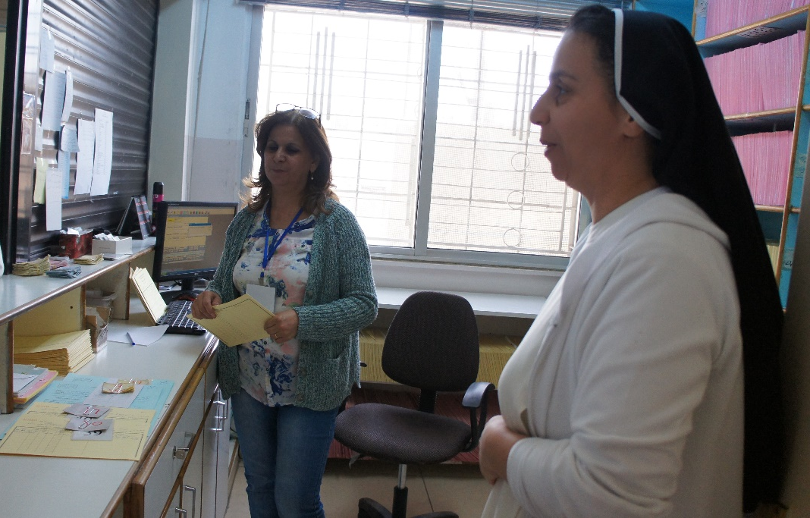
Registration Unit
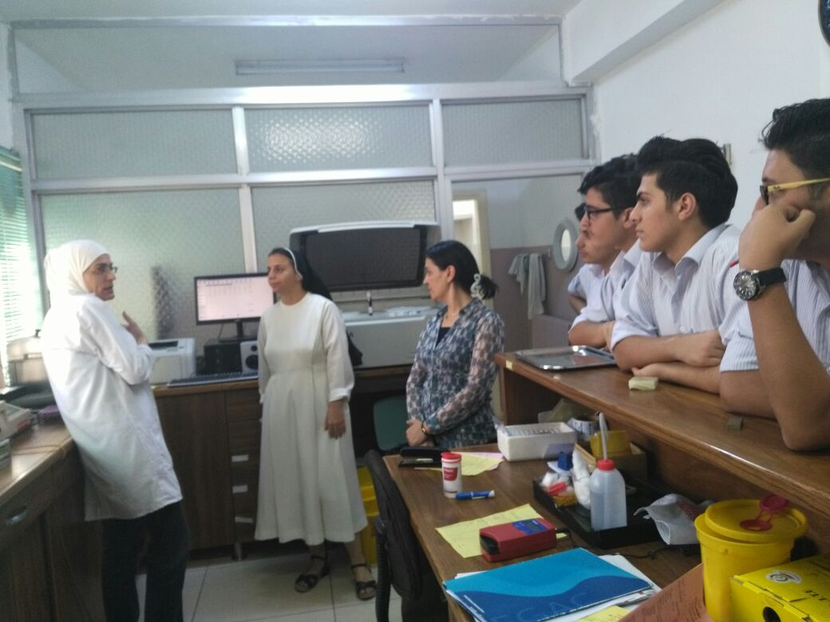
Laboratory

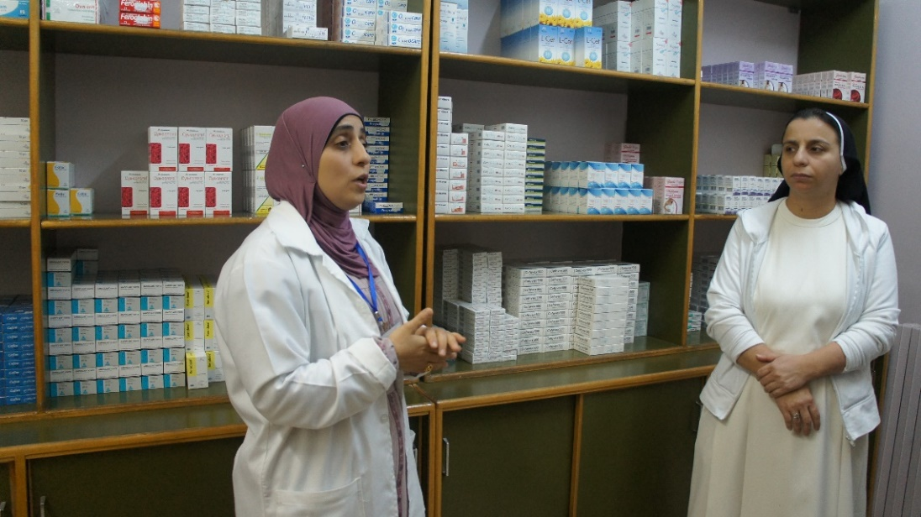

Pharmacy
Estimated Cost 2019:
Amount requested | US$
1. Three Computer programs for the Registration Unit, Laboratory and Pharmacy ($2,120 / each) | 6,360.00
2. Computers/ hardware only with monitors for the Registration unit, Laboratory and pharmacy ($424 / each) | 1,272.00
Total | 7,632.00

Full information regarding our Bank Account:
Arab Jordan Investment Bank (AJIB)
P.O. Box 925286
Amman 11190, Jordan

Tel: +962 (06) 551 8090
Fax: +962 (06) 551 8085 / 551 8075

www.ajib.com
Account Responsible: Companies’ Department
Attn: Pontifical Mission for Palestine
EURO current account
IBAN: JO02AJIB2230006027060370561000
Swift Code: AJIBJOAX600

