Funding Proposal to Caritas Committee, OESSH Netherland
Project title: Finalize the work at the children’s playground in Ader, KERAK
Project ID: M3349
Applicant Name: CNEWA/Pontifical Mission
Postal and e-mail addresses: P.O. Box 6495, Amman 11118 – Jordan
pm.amman@pontificalmission.jo
Tel. 962 6 4649-240
Fax. 962 6 4649-282
Task and position: Ra’ed A. Bahou, Regional Director

Description:
Following-up on the project of the Community Center in Ader, there is only minor work to be done for the children’s playground, by fixing the space for the children to become a safe area to play and enjoy their time, under the protection of the church, parents, older brothers and sisters.

The small part of the playground will need to install artificial grass (turf), in addition of adding some new safer playground toys for the younger children.

This small playground is very important for the young children living in Ader, as no parks are available there. The children will have physical exercise, learning more about their physical and emotional capabilities, socializing with other children their age, learning… and most important it will allow the children to be children, and fulfilling the basic childhood needs by jumping, running, swinging, racing, and yelling...

We also would like to ask the Netherland’s Knights of the Holy Sepulcher to take into consideration Fr. Boulos request to purchase and install a Solar Heater in his church in Kerak, as it will serve the church, the rectory, and the two halls. By installing this Solar Heater, they will save many dinars in their electricity bills and use the savings for other purposes.

Rev. Boulos with a trusted parish’s member visited the markets and showrooms and they provided us with the following offers and prices:

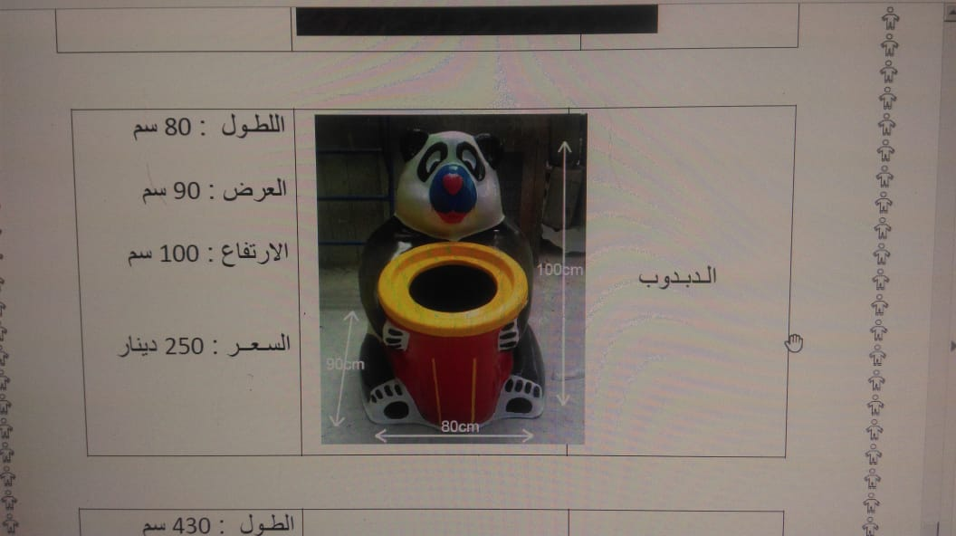No.1
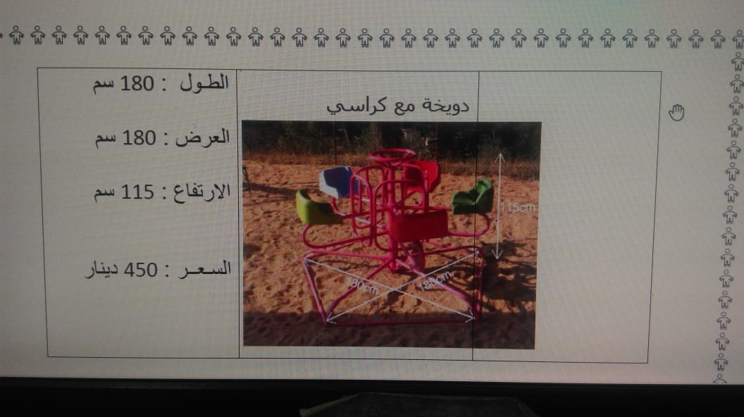
No. 2

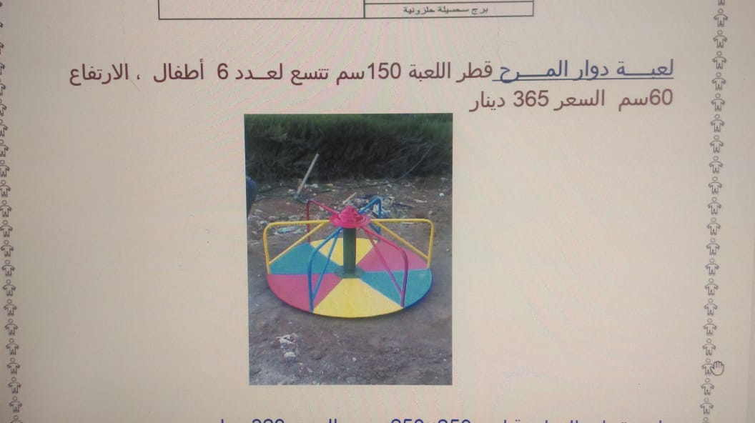

No. 3

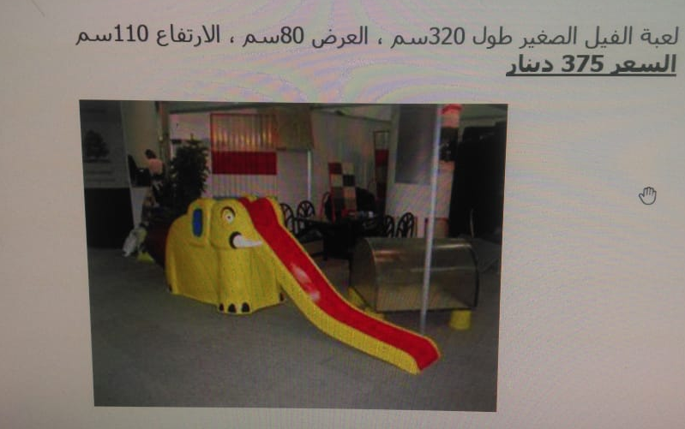

No. 4

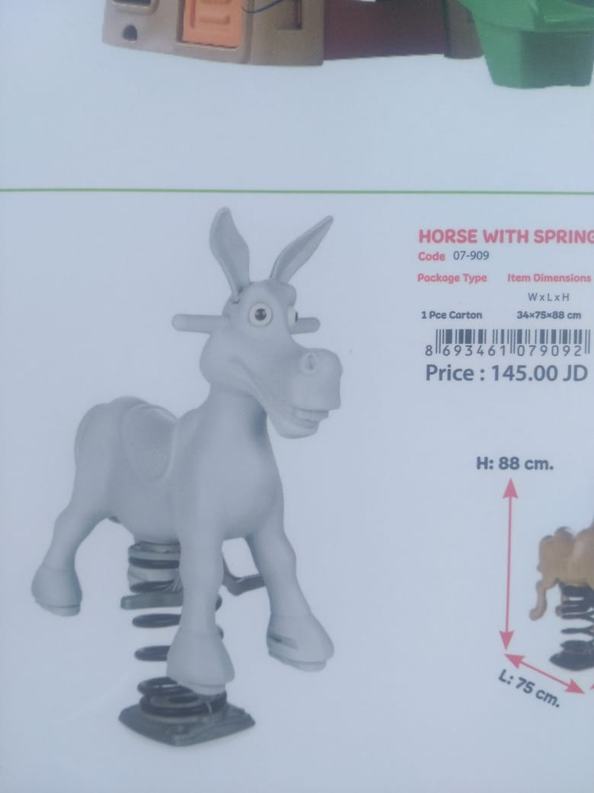

No. 5

Itemized Budget:

Item | Quantity & Price / unite US$ | Total Price US$
Renovate the open air playground, including new play instruments and Solar Heater
Artificial grass for the children’s playground | 200 sq. m*21.186 (this price is after deducting the tax exempt that Fr. Boulos may get as a church | 4,237.20
New play instruments:  No. 1  No. 2  No. 3  No. 4  No. 5 | 1*353  1*516  1*636  1*530  3*205 | 353.00  516.00  636.00  530.00  615.00
Solar Heater with all accessories | New water tank, pipes, base …, and installation cost | 1,108.00
Total amount requested from OESSH |  | 7,995.20

Full information regarding our Bank Account:
Arab Jordan Investment Bank (AJIB)
P.O. Box 925286
Amman 11190, Jordan

Tel: +962 (06) 551 8090
Fax: +962 (06) 551 8085 / 551 8075

www.ajib.com
Account Responsible: Companies’ Department
Attn: Pontifical Mission for Palestine
EURO current account
IBAN: JO02AJIB2230006027060370561000
Swift Code: AJIBJOAX600

